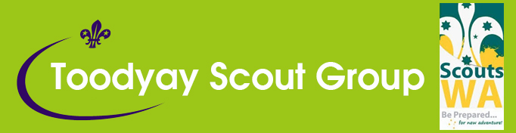

Scouts in Action Week: Creativity
Scout Troop Program: Art Proficiency Badge
Date | Theme | Sub Theme | Meeting Type | Leader in Charge
 | Art |  | Indoor

Time | Minutes | Activity | Equipment | Leader
18:30 | 15 | Parade | All
18:45 | 15 | Activity 1. Artist Relay | Pictures (one set per Patrol) and answer sheets for leader.
19:00 | 60 | Activity 2: Scout Art Skills  You can set up ‘stations’ for this activity, choose one activity, or carry them out over a period of weeks incorporated into other programs. We’ve set up ‘stations’ in this program for a large Troop, but some activities are longer and require more leader assistance.  Stations:  - Painting (patrol symbol on rock)  - Pyrography  - Printmaking  - Photography | You will need some basic art materials, listed within activity - you may be able to borrow equipment from your local school or neighbouring Troop. See lists in activities at end of this document.
20:00 | 15 | Activity 3: Game (Observation or Fast Game) | Butchers paper, black marker pens
20:15 |  | Parade

Activity 1 – Artist’s Relay
Instructions: Print out copies of each of the ten paintings below (one set per patrol)
- Cut out copies of the paintings (without information, one set of ten paintings per Patrol) and hand out sets to Patrols
- Print out a complete set as per below for your own reference and to read out clues
- Get them to write their Patrol names on the back of the copies of the paintings
- Get Patrols to line up relay style at the end of the Hall
- Use pieces of paper numbered one to ten on the wall or floor at the other end
- Leader reads out a ‘clue’ at a time and Patrols must work out which painting corresponds with which number from the information given
- There is a point given for the FIRST correct answer (don’t tell them til the end)
- There is a further point given at the end for the number of correct entries
Scouts may select an artist they are interested in to complete A.) (1) Investigate of the Art badge.

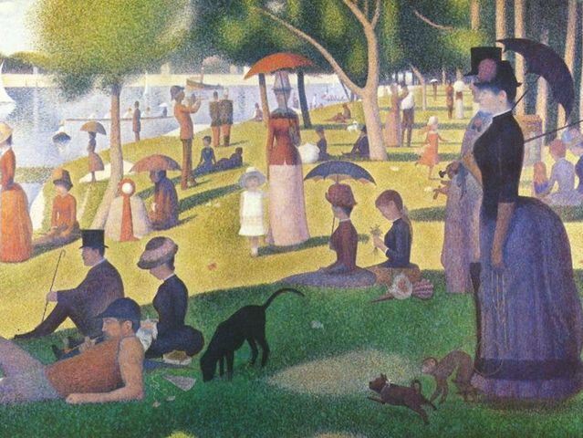
Artist: Georges Seurat - A Sunday on La Grande Jatte
- This painting took the artist over two years to complete
- He finally exhibited it in 1886.
- It was called ‘A Sunday on La Grande Jatte’
- That technique was called the ‘Pointillist’ method.
- It was made by using small, dot like strokes of colour.
- 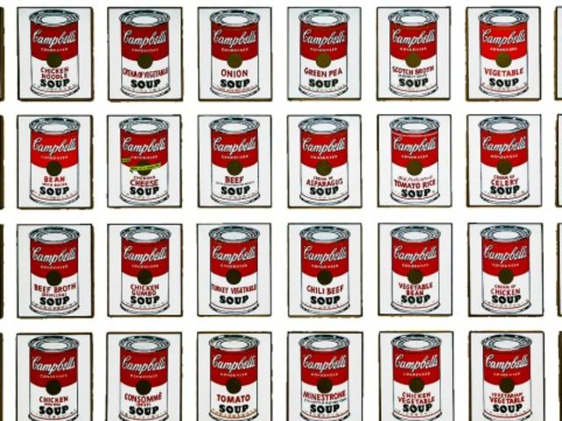

Artist: Andy Warhol – ‘Campbell’s Soup Cans’

- This artist made this artwork in 1962
- When the artist first displayed this artwork, it was displayed on shelves like products in a supermarket
- The artist said he would have the same kind of soup every day for lunch for twenty years
- The artist was inspired by mass produced, printed advertisements
- It was a painting of 32 Campbell’s soup cans

- 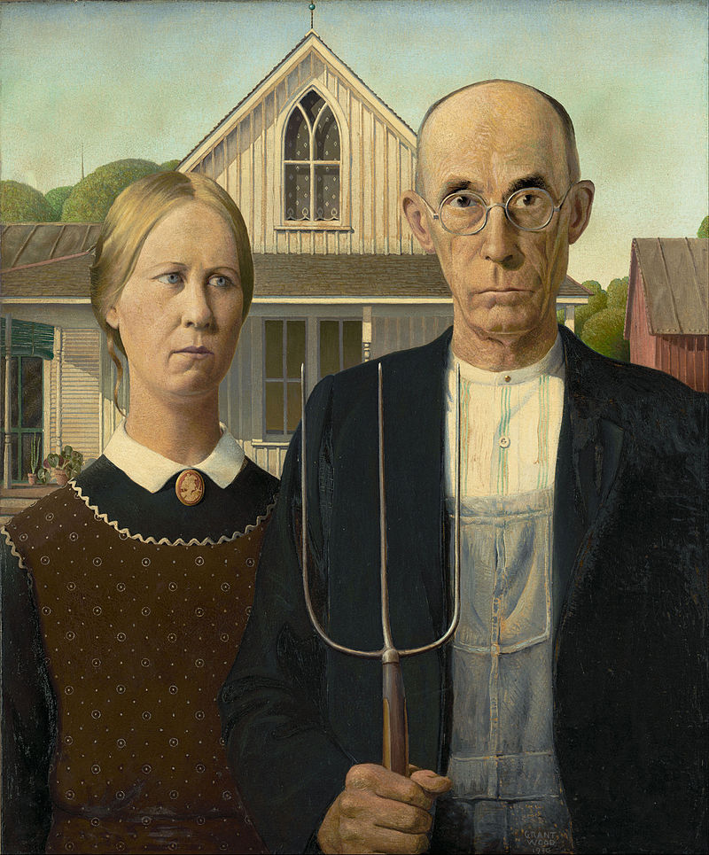

Grant Wood - ‘American Gothic’

- The artist painted this painting in 1930
- It was the first famous painting he’d made
- The artist entered it into a competition and won a $300 cash prize
- This artist said ‘all the good ideas I’ve ever had came to me when I was milking a cow’
- The painting was based on a house he saw and sketched on an envelope

- 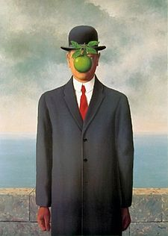
4

Artist: Rene Magritte – ‘The Son of Man’

- It was painted in the surrealist style
- This painting was in the video for Michael and Janet Jackson’s song ‘Scream’
- The artist said of this painting ‘Everything we see hides another thing…there is an interest in that which is hidden and which the visible does not show us’
- In this painting, a man’s arm is bending back at the elbow
- This painting was a self portrait

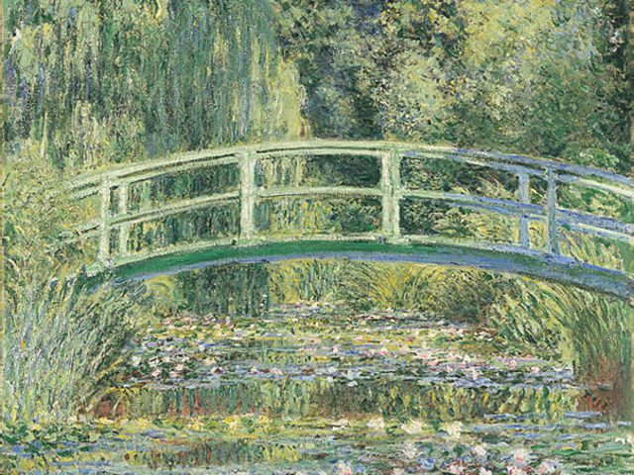
5

- Artist: Claude Monet – Waterlilies and Japanese Bridge
- The artist painted 250 oil paintings of the same thing
- The structure in the painting did not exist until the artist built it himself
- The artist used complementary colours in his paintings
- He had cataracts and painted the last of his series when he was almost blind
- The artist was an avid botanist

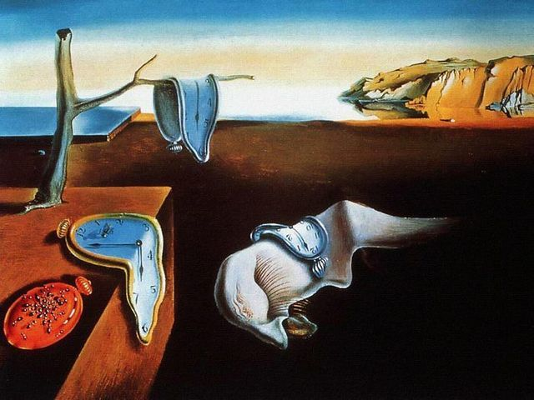
6

- Artist: Salvador Dali: ‘The Persistence of Memory’

- This picture is called ‘The Persistence of Memory’
- He described his work as ‘hand painted dream portraits’
- There is a human hidden figure in the middle of the composition
- This type of art is called ‘surrealism’
- This work is sometimes incorrectly called ‘The Melting Watches’

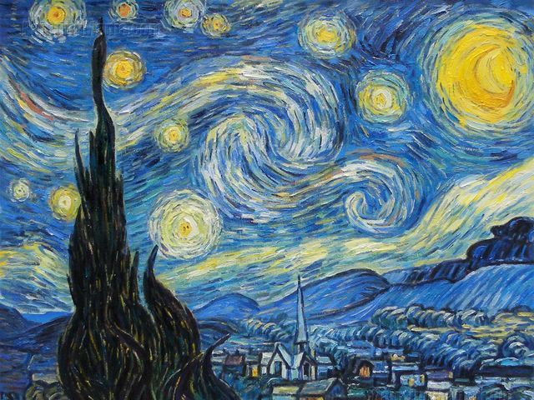
7

- Artist: Vincent Van Gogh – ‘The Starry Night’

- This painting was painted in 1889
- It is from a view of his lunatic asylum window
- This artist cut off part of his own ear
- The artist painted variations of this painting 21 times
- This style of art is called ‘post impressionism’
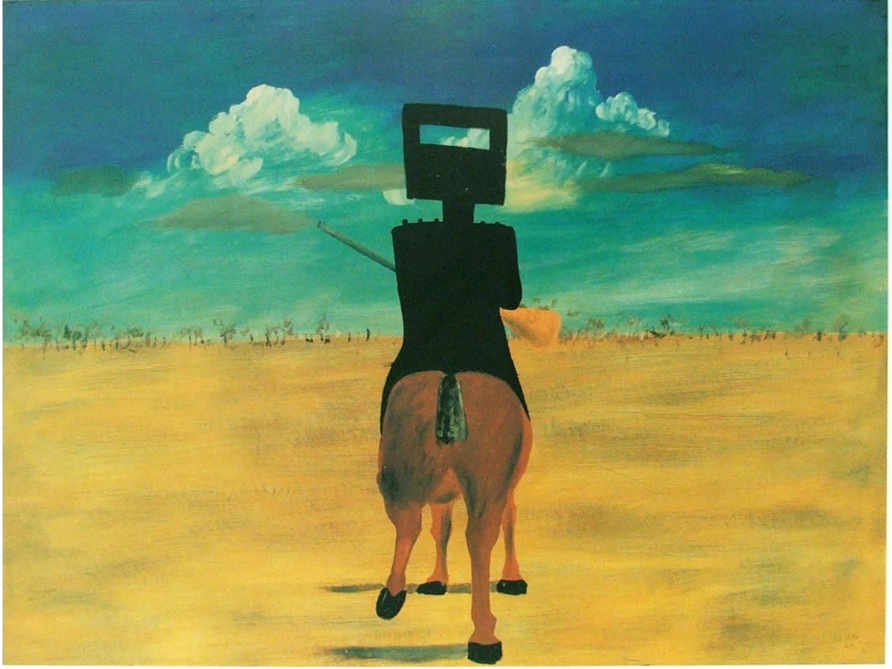
8
- Artist: Sidney Nolan – ‘Ned Kelly’

- This artist was Australian
- The artist’s father was a tram driver
- The artist painted historical characters
- The artist said that he liked to paint the landscape in new ways with the story giving meaning to the place
- The artist was inspired by children’s art

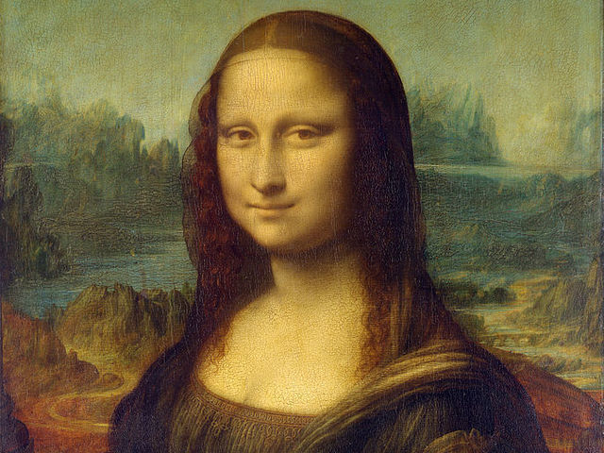
9

- Artist: Leonardo da Vinci – ‘Mona Lisa’

- The painting was painted in the 1500s
- There is another painting under this painting, of a model looking off to the side
- In 1911, this portrait was stolen from the Louvre
- This artist did not draw outlines in his work
- This painting has been described as the best known painting in the world

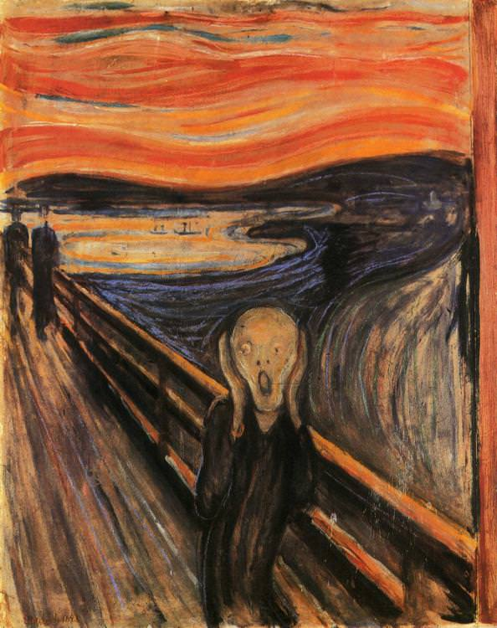
100

- Artist: Edvard Munch: ‘The Scream’

- This painting was painted in 1873
- The artist said of the painting ‘could only have been painted by a madman’
- This painting was stolen then returned in 1994
- The artist made four versions of this painting, as paintings and pastels
- The artist said the painting was inspired by hearing a scream cutting through nature
Activity 2 – Artist’s Stations

Set up four art stations for Scouts to revolve around and learn a new skill.
There are some ideas below, but you can make up your own activity from the range statement in the Art proficiency badge.
Some activities have drying time in between, so make sure you have enough room for Scouts to leave and then come back to their work.
Station 1 – Painting on Rocks
Paint Patrol symbols on rocks – have a Patrol badge there for the Patrol to copy or use as inspiration.
Tell the Scouts about the ‘rocks’ craze (there are groups on social media) – they can ‘plant’ their rocks around their communities once they are finished
How to paint rocks
a) Use natural stones (sold at garden shops or Bunnings) or stones you have collected, make sure you’re allowed to take the stones and that you’re not disrupting any wildlife that might use them as their habitat
b) Wash stones and make sure they are clean and dry
c) Use old newspaper underneath the rock
d) Sketch the design on the rock with pencil
e) Give your rock a coat of paint, paint your design, then seal it with a suitable sealer
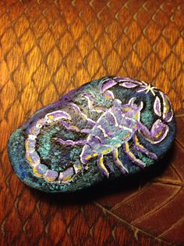

Station 2 – Pyrography Woggle
You can use ‘craftwood’ (balsa wood), another light wood or leather as a ‘face’ for your woggle and then burn in a design. Don’t use MDF. It has formaldehyde in it that releases toxic gases when heated.
Balsa is inexpensive and good for wood burning if you have a pyrography tool at your Scout Hall, but you should make it the right shape – it’s easy to break.
You can use Fimo, leather or a Turk’s Head knot to make the base for the woggle. Make sure you use a suitable glue to attach your woggle to the base.
You could also carve a woggle, but this will take longer.
How to use a pyrography tool
- Make sure your wood or chosen burning object will not be toxic when heated
- Check out your materials – the pyrography tool is hot enough to burn wood and it is hot enough to burn through Scout skin!
- Make sure you do not touch the tip and make sure it goes back into the safety stand, not on a table. Always be mindful where the hot end is.
- Get familiar with your wood-burning tool on a bit of scrap wood and test out ‘drawing’ with the tip – the key is to go slow and steady, if you go too fast, the wood won’t burn like you want it to.
- Use a pencil to sketch your outline (you can draw this on paper first if you like)
- Start burning and use the tip on an angle to drag slowly and make straight lines

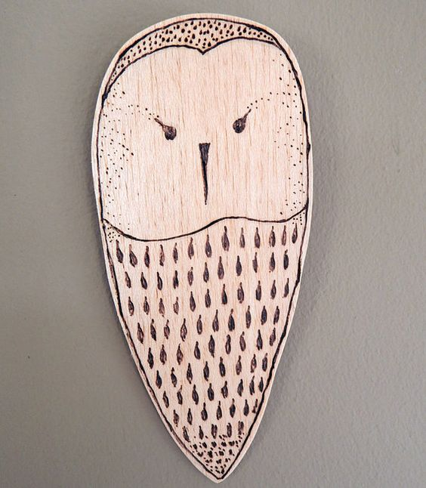

Station 3 – Printmaking
There are three activities below – one is card making using foam board and an intaglio process, one is a collograph process and one is a basic leaf print process which you can do quickly with little drying time (most suitable for a four station activity).
Make a printed intaglio design and make cards
You can find foam core boards at art supply stores like Jacksons or you can use uncoated butchers trays (a pen or carving tool will need to go through it and it is of less use if it is shiny, it’s the uncompressed and raised bits the ink adheres to).
You’ll also need something to use as a tool – you can use pens, but also wooden skewers, chopsticks or the end of a paintbrush. Experiment first by using a small piece of foam.
The printing process is called ‘intaglio’ and you do it by pressing the foam with tools, then rolling on ink with a roller, then printing it onto paper. You can print onto regular photocopy paper but you get a great effect from rice paper (you buy it in rolls from art supply stores).
When your design is completed, you can run it through a scanner and send to Vistaprint (about two dollars each for quantities of ten, or just over a dollar in bulk quantities), moo.com (about thirty dollars for 20 cards) or another printing company for printing, or print cards at home on your printer.
How to make an intaglio print (from artclubblog.com)
You will need:
- Scratch foam board (ask at art supply shops for foam board for printmaking)
- Tools as above
- Sticky tape
- Rubber rollers (borrow from your local school’s art class or community art group if you can)
- Acrylic ink for print making – look for black block printing ink
- Surface for ink, eg piece of glass, perspex or small tray
- Paper or rice paper for printing on
- Tools for applying pressure as above

- Press your design into the foam core. You can sketch lightly on it or draw first on paper. Remember that whatever you print will be reversed, including writing. If you want to reverse your writing, draw it on thin paper first then trace it on a window with a light behind it, then copy to your foam core or use carbon paper.
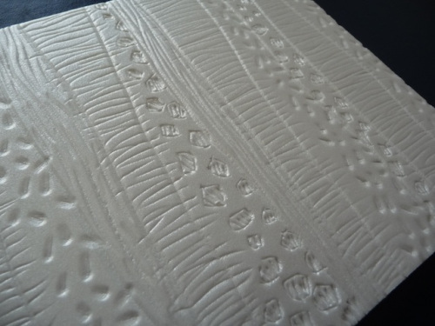

There are some ideas for designs below.

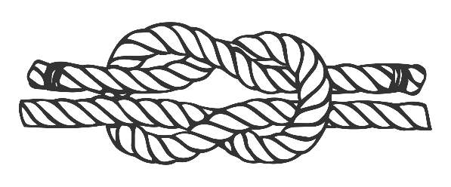

- Once the design is completed, you can add the ink. Put a small amount on a piece of glass or Perspex.
- Use your roller and roll over the paint, being sure to go in all directions. Spread it out evenly and make sure your roller is also covered in ink.
- Secure your foam board to a surface (we cover a table with a plastic table cloth and tape the foam to it with masking tape) and apply the ink evenly.
- Place a piece of paper on top and apply pressure using a clean roller, a baren (this is a special round tool you can buy at art supply shops for a few dollars) or a metal spoon. Cover the whole surface.
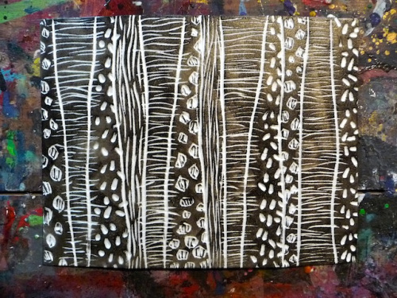
- You can lift up the edge of the paper to see if enough ink has been transferred.
- Carefully remove the paper. You can experiment with different types of paper.
- If you are scanning your prints to make cards, scan them at a high resolution

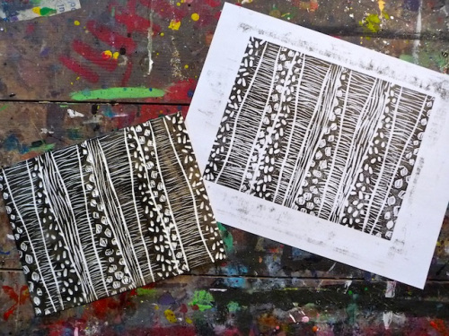

There are more good ideas at artclubblog and other art and craft sites.
https://artclubblog.com/2013/03/11/scratch-foam-printmaking/
How to make a collograph print
A collograph is the above print process in reverse. You can glue slightly flat objects to a piece of board or similar (your ‘plate’) and ink it up.
You can use different materials – string, cardboard, pieces of paper, lace, tin foil, glad wrap, hessian – glued to your ‘plate’ (board or cardboard). Or you can use a combination of collograph and intaglio, where you carve into cardboard that you’ve glued on.
For this process, you are better off with a real printing press, but you can get a decent reproduction by using rice paper or thinner paper and using a roller over the reverse of the paper.
Here’s how to do it:
- Make a plate. You can use any type of sturdy material, cut to size. Sometimes you need to seal the plate before gluing on objects. I don’t bother.
- Glue on low relief materials (flat things) with PVA glue and leave to dry. Collographs pick up fine detail (more so when you use a real printing press). Masking tape works.
- If you use anything that is too thick, it won’t print evenly and it might cut through the paper.
- When the glue has dried thoroughly, give it two coats of varnish or shellac (the Scouts love that it is made of dead bugs) so that you can use it more than once and to stop the paper sticking to the plate. It takes a while to dry, so this might be a two Scout night activity.
- Rub a small quantity of oil into the plate with cotton wool. You don’t have to do this. If you do, wipe it off with tissue.
- Roll up your ink so that your roller is evenly coated.
- Apply the ink to the plate (you should use a stiff relief ink) with a roller – hard rollers will just cover the highest parts, soft rollers can get the ink into different areas of colour, you can make a dollie from a rolled up piece of coarse cloth bound with masking tape – cotton buds, toothbrushes or brushes can all be used to apply ink.
- Wipe off ink or burnish areas with tissue paper or newspaper.
- Print the plate with other damp or dry paper. You can use rice paper (not damp) or watercolour paper that is damp.
Printmaking Hack
An quick and easy way to get a great effect is to use leaves.
- Glue leaves onto board with PVA, or just roll your inked up roller over them. You’ll only get one use per delicate leaves (like fern fronds) or flowers and they sometimes stick to the roller. Be careful when removing bits from the roller.
- You can use this technique with fabric paint or acrylic paint and fabric medium to print on fabric.
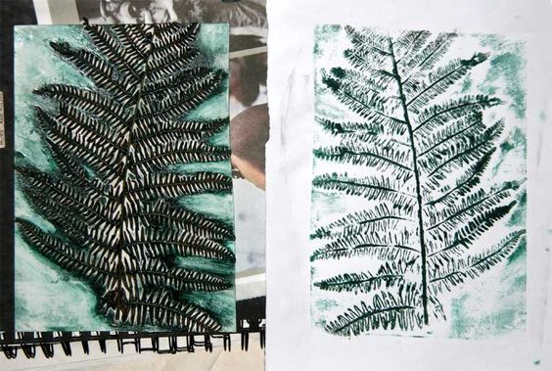
- Cubs could make dilly bags from your printed material.
- You can use different colours to layer your leaf prints

Station 4: Photography
Here are some ideas to help you think about what to include on a ‘photography station’. You can use phones, iPads and real cameras (and a laptop with an SD card slot), or video cameras.
- Selfie Station – Set up a ‘photo booth’ with an iPad and some form of lighting (you can use a desktop lamp or similar, or shine a torch from one side). Ask the Scout to compose their ‘selfie’ using different lighting, or ask them to use different facial expressions. At the end of the night, hit ‘slideshow’ on the iPad to show the Scouts the images.
- Stop Motion – Have the Scouts brainstorm a process that can take multiple steps – we use clay to make action figures, but you can use people carrying out activities or doing basic things like making a sandwich or packing a suitcase. You can use Movie Maker to stitch the photos together on a laptop or use an app on a mobile device to do that for you.
- Get the Scouts to create photo art by giving them a digital camera and asking them to photograph items in or around the Scout Hall that start with a particular letter or series of letters. We used the word ‘Scouts’.
- Ask a Patrol to write a short script and create their own ‘cartoon strip’ by getting Scouts to act out the scene and taking photographs.
- Use small objects and ask Scouts to take macro shots, or create their own DIY macro photo studio for next to nothing – instructions are here https://tinyurl.com/whitelightbox

Activity 3: Games

Observation Game: What’s in the Picture?
- Print a picture at a reasonable size – A3 if possible
- The picture should have a considerable amount of detail in it.
- Give each Patrol pen and paper and ask them to appoint a scribe
- Hand the picture to each Patrol in turn giving them 30 seconds per Patrol to scrutinise it.
- Then set a number of questions to test observation and memory
- Questions might include – was the person’s right or left hand in the air?
- Were there two cars or three cars in the picture?
- What was the object between x and y?
The Patrol with the highest rate of correct answers wins.

Fast Game: Drawing Race
Prepare a series of instructions with at least ten to fifteen steps.
Here is an example.
- Draw a Scout in full uniform
- Draw a tent
- Draw a tree
- Draw a latrine
- Draw a Scout falling out of a tree and almost breaking her arm
- Draw a go kart
- Draw a Scout in the go-kart – etc
Put large sheets of butchers paper doubled over (or sheets taped together) at one end of the hall, one for each Patrol.
Line the Patrols up in relay formation down the other end of the Hall.
Give the Patrols a black marker pen.
Get the Patrol leaders to come to you and hand out the instructions when you say ‘go’. The Scouts must run to the butchers’ paper and draw the first item and use the pen as a relay stick at the other end. Award prizes for well-drawn pictures and first finished.

